Assembling DIY Climate Control™ Remote Sensor

Doug Leppard - May 13, 2014  
Updated: July 3, 2014

# What this kit is

This is a self-contained remote sensor kit designed to be a remote sensor as part of the XBee mesh network. The kit has a standard XBee profile to hold any of the XBee modules. It has a built in 3XAAA battery holder, with a MCP1700 low current voltage regulator and a TMP36 temperature IC.

The printed circuit board has all the pins of the XBee available to add your own circuit to the board. This kit was designed to use as little power as possible so that it can run on 3 AAA batteries. Therefore there are no LEDS or other parts that use battery life.

Features of this kit:

* Housed in an attractive case that can be mounted throughout your home or other locations. It is not water proof.
* 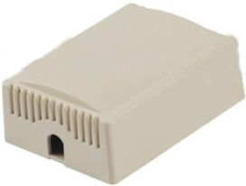AAA battery holder so it is self-contained.
* Built in low current voltage regulator MCP1700.
* Built in TMP36 temperature sensor.
* Optional circuit to monitor battery life of the AAAs.
* All pins of XBee are broken out so additional circuits can be added.
* Three extra VCC and GND connections for additional circuits.
* 26 empty pads to build circuits on board.
* Hole at bottom of box to allow wires to run to external circuits.

# Possible additional circuits that could be added

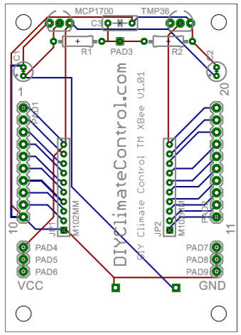All the pins of the XBee are broken out and extra VCC and GND connections are on the board so it makes it easier to add additional circuits. This all depends how the XBee is programmed.

## Water sensor

Circuit could be added where the XBee could transmit when water was found.

## Reed switch

Reed switches could be connected so it could be detected when windows or doors have been opened.

# Parts in Kit

This is a kit, it will be necessary to solder parts onto PCB.

* PCB
* Vented sensor box, L 3 in, W 2.2 in, H 1.1 in.
* MCP1700 3.3V voltage regulator.
* TMP36 temperature sensor.
* 4 mounting screws.
* 4 nylon standoffs.
* 2 1µ capacitors for voltage leveling.
* 2 10 position 2mm headers for XBee mounting. Note XBee and batteries do not come with the kit.

# Assembly instructions

Assemble all the top of the board parts first before the battery holder is added.

## Solder in the 2 2mm sockets

Easiest to put in the two 10 position 2mm headers for the XBee first. That way they can lay flat against the table and the PCB lays on top of them to be soldered.

## Solder 2 caps

Solder on the two 1µ farad capacitors. Both are the same so can go into either slot. They go into C1 and C2. Be sure to put the + side of the capacitor into the + on the board, the longest lead is the + on the cap.

Before you solder them to the board the caps need to be bent down against the board. The case is tight so they need to be bent down so as to fit in the case. See the picture below. Then on the bottom side cut off the extra leads of the capacitors.

## TMP36 temperature sensor

Install the TMP36 sensor next. The MCP1700 and the TMP36 look exactly alike, there are markings on each IC to tell them apart. Put the TMP36 mounted in the board where it is marked TMP36, making sure the flat part of the sensor matches the picture. Push the sensor down as far as it will go, again the case it is in is tight and it cannot be too high. See TMP36 mounted. Cut the extra leads on the back side.

## MCP1700 voltage regulator

Now install the MCP1700. It is mounted on the top left. Mount the MCP1700 to match the marking on the board. Push the IC down as far as it will go. Solder that in place and cuts the leads.

Now all the top parts have been mounted and it should look like this. Do not put in your XBee yet.

To fit the best in the case the MCP1700 and TMP36 need to be bent slightly down towards the bottom of the board.

Note: The two resistors R1 and R2 and C3 are not part of the kit but a place for them are on the board for future use, this will be discussed later.

## AAA battery holder

Now put in the AAA battery holder on the bottom of the board. There are two holes for the battery leads to come through. Mount the board and solder the leads which will be on the top side. Be sure that the battery holder is pressed tightly against the board when you solder it else there will not be enough space to fit in the case.

# testing the board

Do not put in your XBee on the board yet. It would be good to test if everything is working correctly so you will not blow out an expensive XBee.

With the batteries in the holder test if there is about 4.5V on the leads of the battery holder. The voltage will depend on your batteries. Mine with new batteries was 4.78V, anything from 4.0 to 5V is fine.

On the board there have been placed many places to make connections, at bottom are VCC and GND connections. See picture. Put your voltage meter negative lead on the pad marked GND and the meter’s positive lead on the PAD marked VCC. It should read about 3.3v +- .1V.

Now that everything is working well. You can test the TMP36 by putting the meter’s negative lead on a GND connection and the positive lead on pin 20 of the board. Depending on the temperature of the room it should be about .7V.

# Mounting PCB and batteries to case

Next mount the finished board onto the back of the case. There are four spacers and four screws. The top of the PCB that has the TMP36 should be mounted to the top of the case back that has the hole. Put in the spaces with the screws. It should fit snuggly.

The whole setup is so tight using the spacers and screws are optional.

# Mount XBee

Put the XBee in the two 10 position sockets, top of the XBee is pointed to the top of the board. If the XBee has an antenna then is must be bent forward and down. This helps make room for it to be mounted inside the case and the case is designed to be mounted on a wall and thus the antenna will be vertical to ensure the greatest distance for radio signals.

Now put the case together. They should now just snap together. See the picture below be sire the holes are in the right positions, else it does not fit correctly.

# Extra Pads

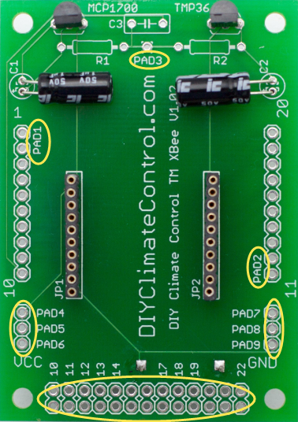There are extra pads on the board to allow adding circuits on the board.

PAD1 is the XBee pins 1 – 10.

PAD2 is the XBee pins 11 – 20.

PAD3 is the special circuit to monitor battery level.

PAD4-6 are VCC (3.3V).

PAD7-8 are GND.

PADs 10 – 22 are not connected pads that can be used to make circuits.